 | VICTORIA JUNIOR COLLEGE  JC 2 PRELIMINARY EXAMINATIONS  Higher 1
CHEMISTRY |  |  | 8872/01
Paper 1 Multiple Choice |  |  |  | 24 September 2010  50 mins
Additional Materials: |  | Multiple Choice Answer Sheet  Data Booklet

READ THESE INSTRUCTIONS FIRST

Write in soft pencil.
Do not use staples, paper clips, highlighters, glue or correction fluid.
Write your NRIC/FIN number, name and CT group on the Answer Sheet.

There are thirty questions. Answer all questions. For each question there are four possible answers A, B, C and D.
Choose the one you consider correct and record your choices in soft pencil on the separate Answer Sheet.

Read the instructions on the Answer Sheet very carefully.

Each correct answer will score one mark. A mark will not be deducted for a wrong answer.
Any rough working should be done in this booklet.

This document consists of 13 printed pages and 1 blank page.
1 Which one of the following has the same number of particles as one mole of copper atoms?

A The number of ions in 2 dm³ of 0.25 mol dm⁻³ of aqueous nitric acid
B The number of delocalised electrons in one mole of magnesium metal
C The number of atoms in 71 g of chlorine gas
D The number of ions in 58.5 g of sodium chloride

2 Arsenic, As (A_{r} = 74.9), is a poison commonly used in pesticides. To determine the mass of arsenic present in a sample of pesticide, all the arsenic was first converted to arsenate ion, AsO₄³⁻. 1.25 × 10⁻³ mol of AgNO₃ was then added to precipitate AsO₄³⁻ as Ag₃AsO₄. The excess Ag⁺ ions needed 18.2 cm³ of 0.0108 mol dm⁻³ KSCN to form silver thiocyanate, AgSCN.

What is the mass of arsenic present in the sample of pesticide?

A 0.015 g C 0.031 g
B 0.026 g D 0.079 g

3 Use of the Data Booklet is relevant to this question.

What do the ions ³⁶S²⁻ and ³⁷Cl⁻ have in common?

A Both ions have more electrons than neutrons.

B Both ions contain the same number of nucleons in their nuclei.

C Both ions have an outer electronic configuration 2s² 2p^{6.}

D Both ions have 20 neutrons in their nuclei.

4 Consider the table below.

Particle | Number of neutrons | Number of nucleons
Q⁻ | 16 | 33
R⁺ | 19 | 39
S²⁻ | 17 | 33
T²⁺ | 18 | 35

Which of the following pairs consists of particles that are isoelectronic?

A Q⁻ and S²⁻ C S²⁻ and T²⁺
B R⁺ and S²⁻ D Q⁻ and T²⁺
5 Elements L and M have the following successive ionisation energies in kJ mol⁻¹.

 | 1st | 2nd | 3rd | 4th | 5th | 6th | 7th
L | 580 | 1800 | 2700 | 11600 | 14800 | 18400 | 23300
M | 1310 | 3400 | 5300 | 7500 | 11000 | 13300 | 20300

What could be the formula of the compound formed by these two elements?

A LM₄ C L₃M₂
B L₂M₃ D L₄M

6 Which of the following species has a trigonal planar shape?

A CO₃²⁻ C NH₃
B SCl₂ D BrF₂⁻

7 Which one of the following statements about the properties of graphite is incorrect?

A It can be used as a lubricant because of the weak forces of attraction between layers of atoms.

B It is a good conductor of electricity in the direction parallel to each layer.

C The carbon to carbon distance between different layers is the same as that within each plane.

D Each carbon atom is bonded to other carbon atoms in a trigonal planar arrangement.

8 Use of the Data Booklet is relevant to this question.

An energy cycle is given below.

ΔH
CH₄(g)
C(graphite) + 2H₂(g)
–75 kJ mol⁻¹
C(g) + 2H₂(g)
C(g) + 4H(g)

What is the value of ΔH in kJ mol⁻¹?

A +350 B +693 C +843 D +1130
9 A student used the apparatus below to heat a can containing 300 g of water.

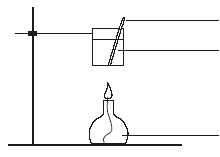
thermometer
can containing 300 g of water
burner containing propan-1-ol

The following data were recorded:
Mass of propan-1-ol burnt = m g
Change in temperature of water = ΔT ºC

You are given that:
Relative molecular mass of propan-1-ol = 60.0
Enthalpy change of combustion of propan-1-ol = −2021 kJ mol⁻¹
Specific heat capacity of water = c J g⁻¹ K⁻¹

What is the efficiency of this heating process?

A 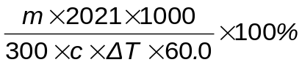 C 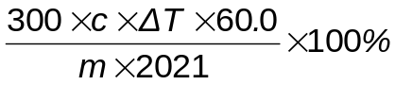

B 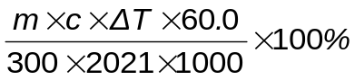 D 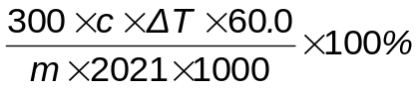

10 Solutions 1 and 2 contain different concentrations of a monobasic acid, X. For each solution, the pH was measured and a 10.0 cm³ portion was titrated with 0.100 mol dm⁻³ NaOH solution. The results are given in the table below:

 | pH of solution | Volume of NaOH needed for titration / cm³
Solution 1 | 2.9 | 10
Solution 2 | 2.7 | 20

Which of the following can be deduced from the given information?

A The concentration of H⁺ in solution 2 is twice that in solution 1.
B Methyl orange can be used to detect the endpoint of each titration.
C A mixture of X and its salt constitutes a buffer solution.
D More NaOH is required for neutralisation if X is replaced by HCl.

11 Azomethane decomposes when heated according to the following equation.

CH₃N=NCH₃(g) → CH₃CH₃(g) + N₂(g)

This reaction is first order with respect to azomethane with a half-life of 20 min.

In one experiment, 16 cm³ of azomethane was allowed to decompose under constant temperature and pressure. What is the time taken for the volume of the reaction mixture to reach 30 cm³?

A 20 min B 37.5 min C 40 min D 60 min

12 Two gases A and B react according to: A(g) + 3B(g) → AB₃(g)

The following results were obtained at 350 K.

Experiment | [A] / mol dm⁻³ | [B] / mol dm⁻³ | Rate of formation of AB₃ / mol dm⁻³ min⁻¹
1 | 0.100 | 0.100 | 0.00200
2 | 0.100 | 0.200 | 0.00800
3 | 0.300 | 0.300 | 0.01800

What is the rate equation for this reaction?

A Rate = k[A] C Rate = k[B]²
B Rate = k[B] D Rate = k[A][B]³

13 Two unlabelled beakers containing equal volumes of 0.5 mol dm⁻³ hydrochloric acid and 0.5 mol dm⁻³ ethanoic acid were given.

Which statement is correct?

A The enthalpy change of neutralisation for the two solutions is the same.
B The rate of reaction with Mg ribbon is the same.
C The volume of H₂ collected when reacted with Mg is the same.
D The initial pH of the two acids is the same.

14 Which statement about indicators is always correct?

A The pK_{a} value of the indicator is within its pH range.
B The pH range is greater for indicators with higher pK_{a} values.
C The colour red indicates an acidic solution.
D The mid-point of the pH range of an indicator is 7.

15 The graphs below show the variation of the percentage of gaseous products present at equlibrium, with temperature and pressure.
pressure
% products
at
equilibrium
(T + 10) ºC
T ºC

Which one of the following systems could the graphs represent?

A N₂(g) + 3H₂(g) ⇌ 2NH₃(g) ΔH = –92 kJ mol^{–1}
B 3O₂(g) + 4NH₃(g) ⇌ 2N₂(g) + 6H₂O(g) ΔH = –1248 kJ mol^{–1}
C 2N₂(g) + O₂(g) ⇌ 2N₂O (g) ΔH = +82 kJ mol^{–1}
D CO₂(g) + C(s) ⇌ 2CO (g) ΔH = +173 kJ mol^{–1}

16 The chloride of an element R of the third period is a liquid which has a boiling point of 76 ºC and fumes in air.

After mixing 0.010 mol of the chloride with water, the resulting solution required 0.030 mol of silver nitrate for complete precipitation of the chloride ion.

To which Group of the Periodic Table does R belong?

A V B IV C III D II

17 Beryllium resembles aluminium in its chemical properties.

Which property of beryllium compounds is unlikely to be correct?

A Beryllium oxide can undergo reaction with aqueous sodium hydroxide.
B Beryllium chloride can form the dimer Be₂Cl₄.
C Beryllium chloride is an ionic compound.
D Beryllium chloride dissolves in water to give an acidic solution.

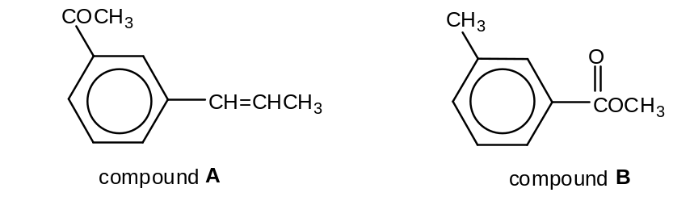18

Which of the following reagents will distinguish compound A from compound B?

A hot acidified KMnO₄ C ethanolic KCN
B aqueous bromine D Fehling’s solution

19 Which of the following 2-stage processes will not yield the final product as shown?
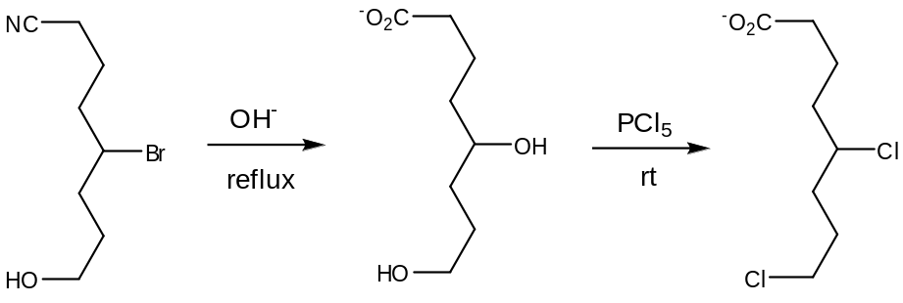

A

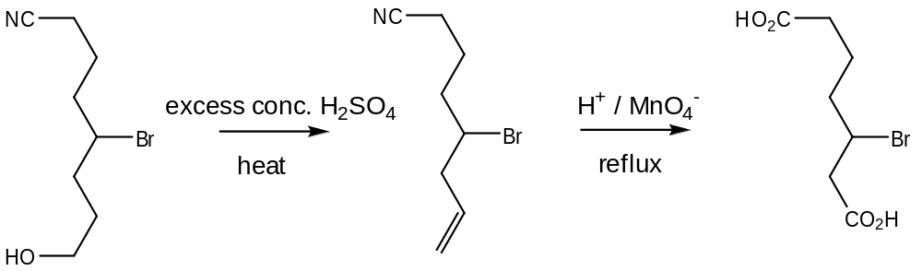

B

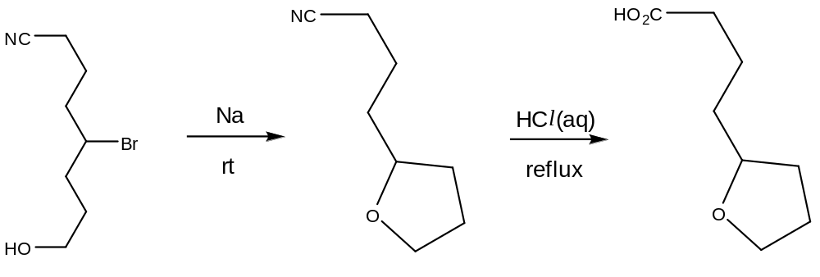

C

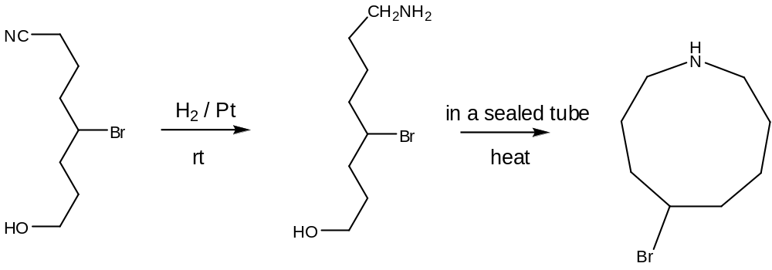

D

20 Which of the following compounds react with hot acidified KMnO₄ and the resultant product formed will give a positive test with both 2,4-dinitrophenylhydrazine and PCl₅?
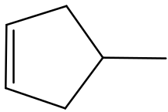

A

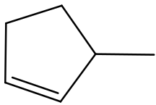

B

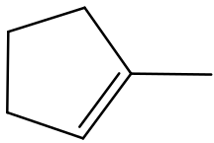

C

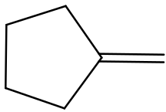

D

21 Why does the reaction C₂H₅X + OH– → C₂H₅OH + X– occur faster if X is iodine instead of bromine?

A The C–Br bond is stronger than the C–I bond.
B The C–Br bond is more polar than the C–I bond.
C The I– ion is less hydrated in water than the Br– ion.
D The overlapping of C–Br orbitals is less effective than that of C–I orbitals.

22 Compound R has the structural formula shown below.

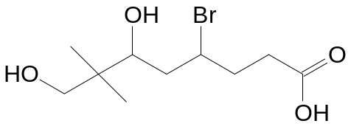

Which of the following reagents will not undergo any reaction with compound R?

A aqueous sodium carbonate C ethanolic ammonia
B phosphorus pentachloride D Brady’s reagent

23 Compound M can be synthesised as shown below.

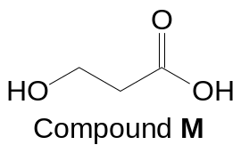

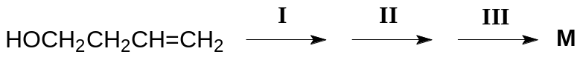

What are the reagents used for steps I, II and III?

 | I | II | III
A | 1. concentrated H₂SO₄  2. H₂O | NaOH(aq), I₂(aq) | HCl(aq)
B | 1. concentrated H₂SO₄  2. H₂O | OH–/KMnO₄(aq) | HCl(aq)
C | H⁺/KMnO₄(aq) | PCl₅ | NaOH(aq)
D | H⁺/KMnO₄(aq) | PCl₅ | H₂O

24 Acarol is sold as an insecticide for use on fruit and vegetables.

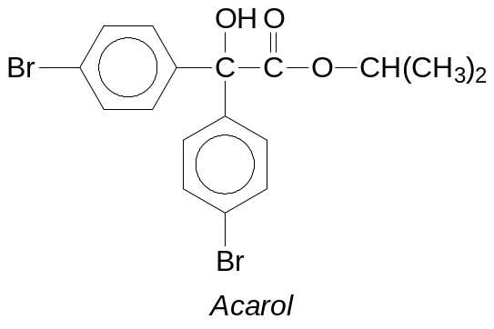

The final stage in its manufacture is an esterification.

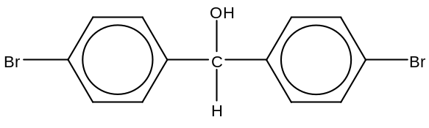 Which alcohol is used to form the ester?

A di(4–bromophenyl)methanol,
B ethanol
C propan–1–ol
D propan–2–ol

25 One industrial preparation of ethanoic acid is the direct carbonylation of methanol using a rhodium catalyst.

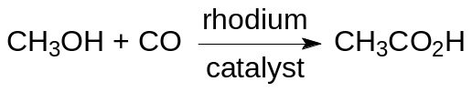

Which compound could be used to produce 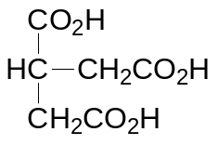 by this method?

A 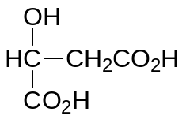
B 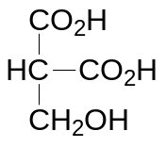
C 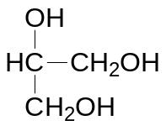
D 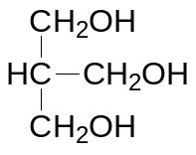

Section B

For each of the questions in this section, one or more of the three numbered statements 1 to 3 may be correct.

Decide whether each of the statements is or is not correct (you may find it helpful to put a tick against the statements that you consider to be correct).

The responses A to D should be selected on the basis of

A | B | C | D
1, 2 and 3  are  correct | 1 and 2  only are  correct | 2 and 3  only are  correct | 1 only  is  correct

No other combination of statements is used as a correct response.

26 Carbon disulphide, CS₂, is a volatile flammable liquid used in the manufacture of cellophane. On combustion, CS₂ is oxidised as follows.

CS₂(g) + 3O₂(g) → CO₂(g) + 2SO₂(g)

Which statements are correct?

1 When 20 cm³ of CS₂ is reacted with 100 cm³ of oxygen, 60% of the final gas volume will dissolve in aqueous alkali.
2 38.1 g of CS₂ will react exactly with 33.6 dm³ of O₂ under standard temperature and pressure.
3 When 30 cm³ of CS₂ is reacted with 60 cm³ of O₂, 30 cm³ of CO₂ will be produced.

27 Which trends across the third period (Na to S) are always true?

1 The bonding in the oxide changes from ionic to covalent.
2 The first ionisation energy generally increases.
3 The ionic radius decreases.

The responses A to D should be selected on the basis of

A | B | C | D
1, 2 and 3  are  correct | 1 and 2  only are  correct | 2 and 3  only are  correct | 1 only  is  correct

No other combination of statements is used as a correct response.

28 The diagram shows the energy profile of a reaction, 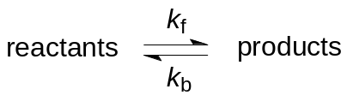 where k_{f} denotes the rate constant of the forward reaction and k_{b} denotes the rate constant of the backward reaction.
Potential energy
Reaction profile
reactants
products
E_{a}
ΔH
Which statements are correct?

1 k_{f} and k_{b} will increase in the presence of a catalyst.
2 Heating the equilibrium mixture will increase k_{f} but decrease k_{b}.
3 k_{f} will increase when the concentrations of reactants are increased.

29 Which compounds could undergo elimination reaction when treated with hot ethanolic sodium hydroxide?

1 (CH₃)₃CBr
2 (CH₃)₂CHBr
3 (CH₃)₃CCH₂Br

30 Which reactions would produce benzene–1,3–dicarboxylic acid?

1 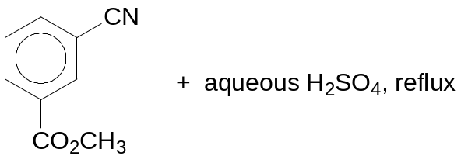
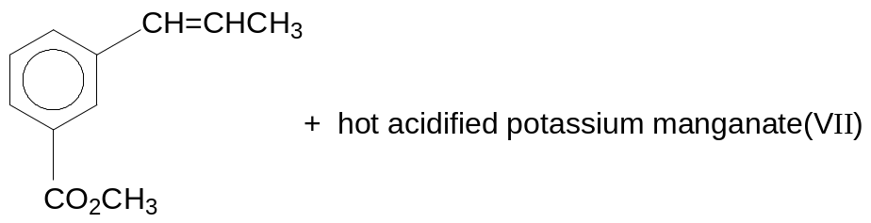

2

3 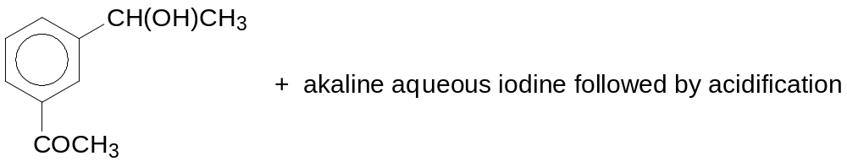

2010 Prelim H1 P1 Chemistry Answers

Paper 1: Multiple Choice

1 A | 2 B | 3 D | 4 A | 5 B
6 A | 7 C | 8 B | 9 D | 10 C
11 D | 12 C | 13 C | 14 A | 15 D
16 A | 17 C | 18 B | 19 D | 20 C
21 A | 22 D | 23 A | 24 D | 25 C
26 B | 27 B | 28 D | 29 B | 30 A

BLANK PAGE

